*ecse 211 design project*

Hardware Document

Version *1.07*

*04/08/2018*

*ECSE 211 TEAM 11*

VERSION HISTORY

|  |  |  |  |  |
| --- | --- | --- | --- | --- |
| **Title** | Hardware Document | | | |
| **Description** | Keeps track of all Hardware related design and building | | | |
| **Created By** | Enan Ashaduzzaman, Hardware Team Manager | | | |
| **Date Created** | 2st March 2018 | | | |
| **Version Number** | **Modified By** | **Modifications Made** | **Date Modified** | **Status** |
| 1.00 | Enan Ashaduzzaman | Created the Document. Asserted 3 possible preliminary designs coupled with their respective advantages/disadvantages | 2nd March, 2018 |  |
| 1.01 | Luka Jurisic | Peer reviewed the document. Formatted the Document | 3rd March, 2018 | Preliminary Week 2 submission Content complete |
| 1.02 | Enan Ashaduzzaman  Luka Jurisic, | Enan-Added section 4-Comparison of designs.  Luka-Removed possible design #2 as it was completely unfeasible. Formatted the document. | 12th March, 2018 | Wheel design chosen. Building must follow |
| 1.03 | Enan Ashaduzzaman | Enan-Added Sections 5, 6, & 7 | 22nd March, 2018 | Final Design (Version 1.0) Completed |
| 1.04 | Enan Ashaduzzaman | Enan-Added to Section 5.  Edited Section 6 & 7 | 28th March, 2018 | Final Design (Version 2.0 Completed |
| 1.05 | Luka Jurisic,  Bryan Jay | Luka- Added extensively to the design process section. Tidied up contents page. Labelled all the figures, edited previously written sections.  Bryan- Created the Mechanical Mechanisms flowchart | 29th March, 2018 | Hardware documentation is on schedule. Ultrasonic Sensor needs to be included in the building process. |
| 1.06 | Enan Ashaduzzaman | Enan-Added subparts to sections 6 and 7 | 4th April, 2018 | Hardware document is on schedule. Changes will be made along the way if the robot is changed. |
| 1.07 | Enan Ashaduzzaman | Enan-Added subparts to section 6 | 7th April, 2018 | Hardware document is on schedule. Changes will be made along the way if the robot is changed. |

TABLE OF CONTENTS

# 1 Table of ContentS ………………………………………………………..

# 2 Design Process …………………………………………………………….

# 2.1 Base Progression and Iterative System Evolution………………………………….

# 2.2 Preliminary to Final Design Progression…………………………………………

# 2.3 Presentation ……………………………………………………………………..

2.3.1 Pictures ………………………………………………………………….

# 2.3.2 LDD Files …………………………………………………………………

# 2.4 Design Niche ……………………………………………………………………

# 3 Flowchart ………………………………………………………………….

# 4 PrelimAnary Designs …………………………………………………….

4.1 Prelimanary Design #1 ……………………………………………………………

4.2 Prelimanary Design #2………………………………………………………………

# 5 Comparision of Designs ……………………………………………………

# 6 Final Design

6.1 Robot Version 1.0 …………………………………………………………………..

6.1.1 Version 1.0 ……………………………………………………………………

# 6.1.2 Version 1.1 ……………………………………………………………………

6.2 Robot Version 2.0 …………………………………………………………………..

6.2.1 Version 2.0 ……………………………………………………………………

# 6.2.2 Version 2.1 ……………………………………………………………………

# 6.2.3 Version 2.2 ……………………………………………………………………

# 7 Building process ……………………………………………………………..

7.1 Chassis …………………………………………………………………………….

7.2 Variable Rear Wheel………………………………………………………………..

7.3 Light Sensor (Colour Detection)…………………………………………………….

# 8 Final Design History

# 2 DESIGN PROCESS

# 2.1 Base Progression and Iterative System Evolution

The Systems, Constraints and Requirements documents provide the underlying base for the hardware design process. The given hardware available coupled with the specific requirements of the client allowed an initial plan layout for the entire design. A flowchart outlining the necessary components and their integration was developed and used as over- arching guide.

This guide lended itself to an iterative design procedure that allowed testing immediately after a component was constructed. This ensured that each component was performing efficiently before it was added to the main prototype designs. Following this, integration testing was conducted to ensure component compatibility.

**2.2 Preliminary to Final Design Progression**

In the preliminary stages of the project, 3 main designs were created to narrow down the multiple ideas that the team had. These designs and ideas mainly came from the research and development phase of the project. From previous experiences of the past five labs, all three teams put their knowledges together in order to think of the best suitable designs for the robot.

As the project progressed, it was quickly realized that our 3rd design was completely impractical, and it was discarded. Following this, the two remaining designs were built and tested. The advantages and disadvantages of each designs were looked at and through testing, and the necessary modifications and decisions were made in the run-up to deciding upon a final design. This initial process was very important because it is much harder to alter a poor final hardware design than it is to modify the software, and thus stringent testing ensured that our design met the necessary requirements. Though, following software integration into the system, small modifications were constantly made to the final design throughout the final part of the project.

**2.3 Presentation**

**2.3.1 Pictures**

The progression of the robot throughout the design process is made visually clear through the use of a multitude of pictures. Please refer to the appendices for detailed reports.

**2.3.2 LDD Files**

Coupled with pictures, LDD designs are included in this document to allow a step by step recreation of the final design of the robot. The design also helps to illustrate the wiring and port connection of the robot.

**2.4 Design Niche**

Considering that our design is being compared to other design teams that have also been contracted by the client, our team wanted to create a unique design that differentiated itself from the many competitors. We believe we have done just this by implementing a variable real wheel design that acts as “landing gear” for our robot during the bridge traversal. Of course, complexity does not mean superiority in design, but we hope to indicate that through this report as well as our demonstration that our complexity does not compromise other requirements of the client.

**3 FLOWCHART**

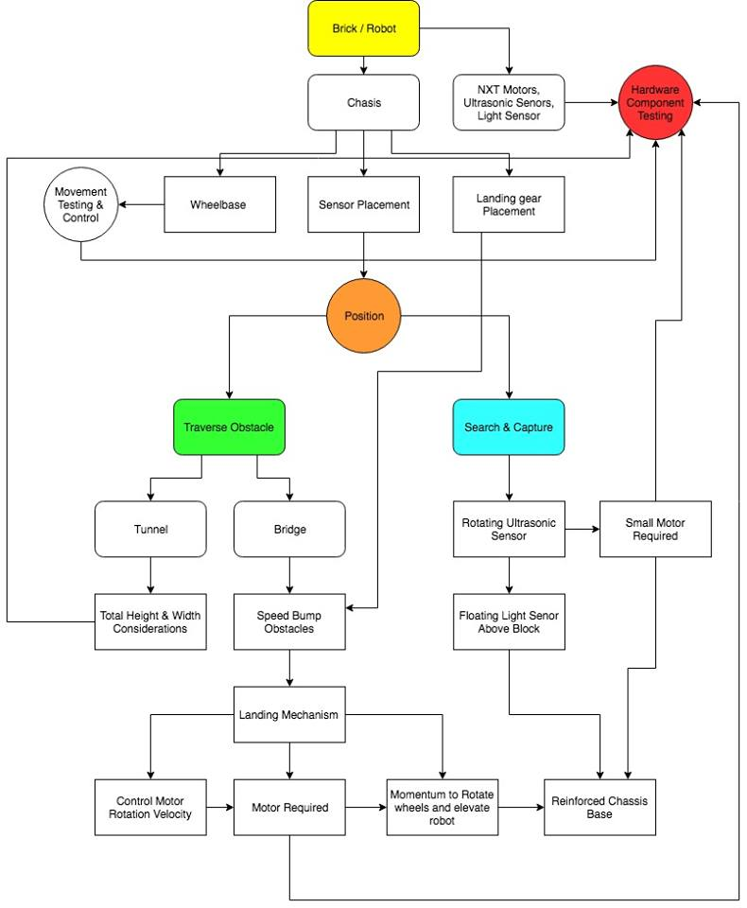

*Figure 3.1- Mechanical Mechanisms Flowchart*

# 4 PrelimAnary Designs

**4.1 Prelimanary Design #1**

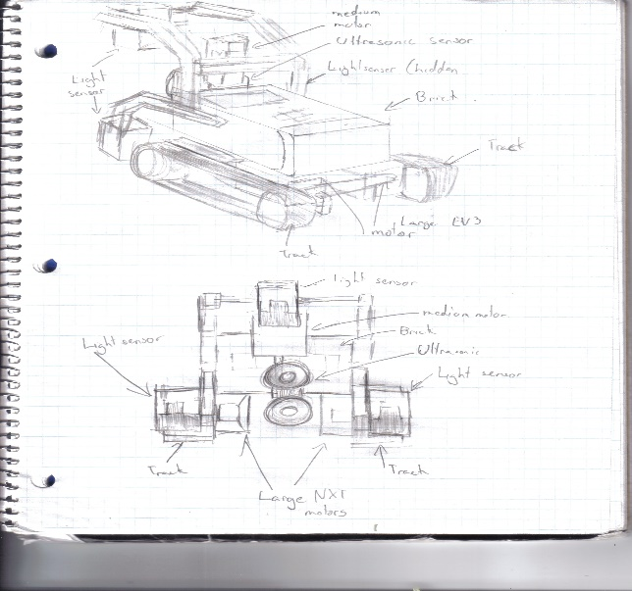

**Features**

The design consists of three main features. The robot will be utilizing the track belt rather than the traditional wheels. The wheels will be attached to two large EV3 motors as they are better structured than the previous generation. With the better traction of the belt, it is believed that the robot will have more grip, thus helping it overcome the bumps that it will encounter on the bridge. Moreover, on each side of the robot, there will be a light sensor. These light sensors will be used for the odometer correction. From previous labs, it was understood how important it is for the robot to navigate properly, thus the two light sensors will help with the accuracy of the robot’s navigation.

Furthermore, the variable ultrasonic sensor in front of the robot will help it detect blocks on all three sides of the robot. Finally, the robot will use another light sensor which will be placed about 11cm off the ground. This sensor will be used to detect the colors of the blocks. By keeping the light sensor at a constant height, it will be able to detect the colour of the blocks more effectively without reading error.

**EV3 Sensors and Motors**

* 3 light sensors (2 used for localization, 1 used for colour detection)
* 1 ultrasonic sensor
* 2 Large EV3 motors
* 1 Medium EV3 motor

**Advantages**

By using the track belt rather than the wheels, the robot will be able to overcome the bumps more efficiently. Moreover, this method is a simpler approach without the need of creating a complex variable track. The use of two light sensors will be very important as it will output more accurate results for the robot’s navigation. The variable ultrasonic sensor allows the robot to detect blocks on every side of the robot without the use of multiple sensors. Finally, having the variable ultrasonic sensor will decrease the need of having multiple ultrasonic sensors on each side of the robot, thus simplifying the design process of the robot.

**Disadvantages**

The use of the track belt as the wheels will most likely not be as accurate as the traditional wheels. Also, having the robot speed through the bumps might ruin the navigation. Finally, using the two light sensors for odometer correction is a method been used by anyone in the group.

**4.2 Prelimanary Design #2**

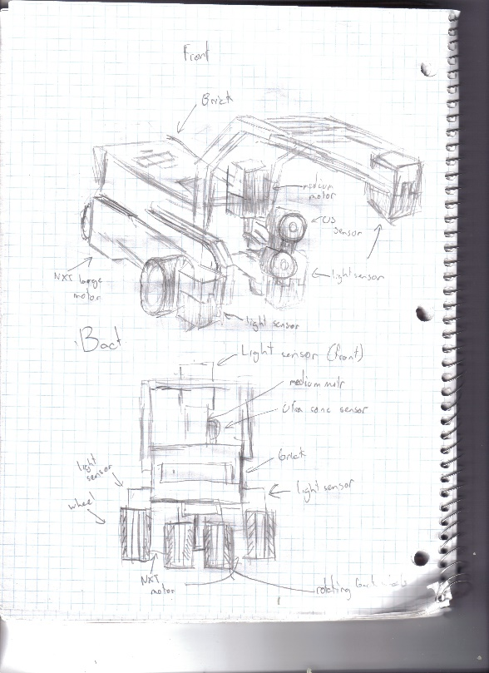

**Features**

This design is very similar to “Preliminary Design #1.” The main difference is that this design uses the traditional wheels which were utilized from labs one to five. There’s also going to be a wheel at the back end supporting the robot (similar to the design of a plane). This wheel will be able to rotate whenever needed. Similar to Design #1, two light sensors will be used for the odometer correction and one light sensor will be placed about 11cm from the floor to detect the colours of the block.

The two light sensors will allow for more accurate navigation results. Having the light sensors, a fixed distance from the blocks allow for more precise readings of the colours. One variable ultrasonic sensor will be implemented to detect blocks on all three sides of the robot. The ultrasonic sensor will be attached to a medium motor, allowing it to turn. The idea behind this robot is to have one half of the robot traveling on water while having the other half of the robot traveling on the bridge, mainly on the portion that is not affected by the bumps. This idea still needs to be confirmed by the professor.

**EV3 Sensors and Motors**

* 3 light sensors (2 used for localization, 1 used for colour detection)
* 1 ultrasonic sensor
* 2 Large EV3 motors
* 1 Medium EV3 motor

**Advantages**

Advantages of this robot includes that the wheels are more accurate at navigation than the belt system. The robot itself is also a simple design without the complicated variable track method. Having the variable ultrasonic sensor allows the robot to detect objects on every side without the use of multiple ultrasonic sensor. Keeping the light sensor at a constant height to detect the block colours is a more efficient and accurate method. Finally, the use of two light sensors as a form of odometer correction will be more accurate than having a single light sensor on the back end of the robot.

**Disadvantages**

This idea is just a proposition as the group doesn’t know if this method will be accepted by the professor. Also, using the two light sensors for odometer correction is a method that the group never worked with before.

# 5 COMPARISONS OF dESIGNS

***Design #1***

During the first implementation of the treads, it was noticed that the treads were loose. Since the wheels were no spanning the entire length of the tread, they weren’t working to the best of their ability. The loose treads were evident when the robot tried to complete the square navigation. Visually, it was obvious the robot was not going in a straight line at all times.

During the second implementation of the treads, the front wheel was lifted lightly in order to slightly secure the treads. Having the front wheel lifted also helped with the traction as it made it easier for the robot to travel through the bumps. At the end of the day, the robot still had trouble in the navigation portion. The little errors compiled together at the end of the navigation.

***Design #2***

On the first design of the robot with regular wheels, a single marble was placed to carry the weight of the back end. Two wheels were placed on each motor to increase traction. While the robot seemed to complete the square navigation better than the treads, it had multiple issues crossing the bridge. The single marble at the back end changed the direction of the robot extensively. At the end, the robot couldn’t plow through the bumps on the bridge.

On the second design, two marbles were placed on the back. A marble was placed on each corner of the back end hoping the robot would be able to travel straight through the bumps better. While the robot traveled better than the first design, it still encountered complications when traveling though the bumps. The robot barely made it passed the bumps on the bridge. This concluded that the marbles were not a viable option to support the back end of the robot.

***Conclusion***

After taking everything into consideration, it was finalized that the regular wheels *(design #2)* will be over the treads. Even though the treads traveled through the bumps more efficiently, the regular wheels were not far behind. Considering navigation will be a huge factor in completing the tasks, it is important to use the hardware that best perfects the navigation with ease.

# 6 Final Design

***6.1 Robot Version 1.0***

**6.1.1 Version 1.0**

# 

*NXT Brick*

*Light sensors for Object Detection*

*Variable real wheels (Stored position)*

*Light sensors for Localization*

*Ultrasonic Sensor*

*Figure 6.1.2- Front view of version 1.0*

*Figure 6.1.1- Back view of version 1.0*

The first version of the final robot was built mainly based on the foundation of Preliminary Design #2. There was only one major change implemented on Preliminary Design #2, the back wheel which supports the robot is only used when the robot is crossing the bridge. Through testing, it was realized that the robot is only able to cross the bridge when the back wheels are stabilized.

Moreover, it was realized that the robot performs the localization best when it is supported by the marble in the back end. Keeping all this in mind, the major implementation was to attach the back wheels to a Large EV3 motor (Figure 5.1.1). The robot will initially be supported by the marble. When the robot localizes towards the bridge, the Large EV3 motor will lower down the back wheel to allow the robot to successfully traverse the bridge.

Once the robot has passed the bridge, the motor will pull the wheel up allowing the robot to land on the marble and continue to its destination. Other than that, everything else from Preliminary Design #2 was carried onto the first version of the robot.

**EV3 Sensors and Motors**

* 3 light sensors (2 used for localization, 1 used for colour detection)
* 1 ultrasonic sensor
* 3 Large EV3 motors (2 used for the front wheels, 1 used for variable rear wheel)
* 1 Medium EV3 motor

**Advantages**

* Variable Rear Wheel: The rear wheel is brought down only when the robot is traversing the bridge. The stable wheel allows the robot to traverse the bumps through the bridge effectively. When the robot completes traversing the bridge, the rear wheel is lifted back up allowing the robot to use the marble during localization.
* Variable Ultrasonic Sensor: The ultrasonic sensor is attached to a medium motor allowing it to rotate 90 degrees. This implementation allows the robot to work with one ultrasonic sensor rather than having two ultrasonic sensors.
* Two Light Sensors (Localization): Two light sensors were placed in front of each front wheel rather than using a single light sensor. This allows for more accurate localization which is essential in the final project.
* Stable Light Sensor (Colour Detection): The light sensor used for colour detection is placed exactly 10.9cm off the ground. Given the fact that the blocks are 10.1cm tall and the light sensor’s optimal range is 0.2cm to 1.5cm, the stable height of the light sensor allows is to always detect the colour in its optimal range (0.8cm away from the block at all times).

**Disadvantages**

* Making the robot implement and lift the rear wheel when traversing the bridge can be time consuming. (Robot will have to re-localize after the bridge)
* The marble on the rear end of the robot causes it to tilt down. This leads to minor problems when trying to go through the bumps.
* The ultrasonic sensor on the right side of the robot is not in the ideal position. By not having the ultrasonic in the middle with the light sensor (colour detection), blocks will not always be detected by the light sensor during colour detection.
* The robot has a long wheelbase which may be an issue during the navigation.

**6.1.2 Version 1.1**

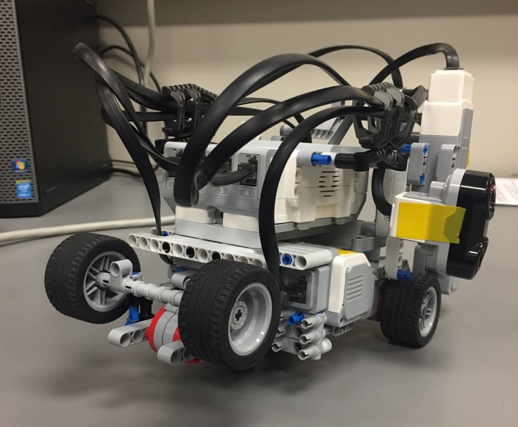

*Stopper implemented*

*Figure 6.1.3- Back view of version 1.1 with the stopper*

**Updated Hardware Change**

Following the completion of the *Back Wheel Functionality Test* on hardware version 1.0 (see testing document), the addition of a stopper was implemented at the back of the robot. The stopper was implemented so that the motor doesn’t overturn when lifting the landing gear and to aid the robot to turn the variable back wheels to its optimal angle at all times.

***6.2 Robot Version 2.0***

**6.2.1 Version 2.0**

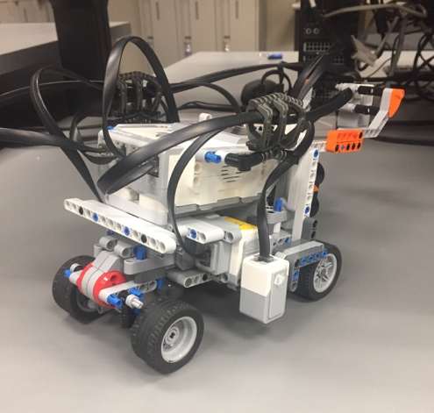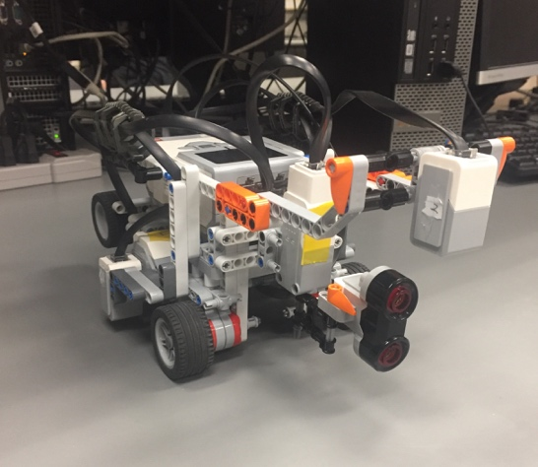­­­

*Bioni (stopper)*

*Wire management clamp*

*Variable real wheels -Ejected Position*

­

*Light sensor- adjusted to centre side of robot*

*Ultrasonic sensor- moved from side to centre*

*Figure 6.2.1*

*Figure 6.2.2*

The second version of the robot was built from scratch due to the imperfections that were realized from testing. The second version is built on the same platform and features of the first version. First and foremost, the marble on the rear end of the robot is not tilting the robot downwards. This enables the ultrasonic sensor to face frontwards rather than being angled down along with the robot.

Moreover, the location of the two light sensors *(Figure 6.2.1)* is now behind the front wheels. This change allows gets rid of all the clutter in front of the robot. Additionally, the change freed up space to place the ultrasonic sensor in front of the robot *(Figure 6.2.2),* the most ideal position since the light sensor (colour detection) is also located in front of the robot.

Finally, this version of the robot is more condensed compared to the final robot. Unnecessary pieces were taken off the robot allowing the robot to be less bulky than before.

**EV3 Sensors and Motors**

* 3 light sensors (2 used for localization, 1 used for colour detection)
* 1 ultrasonic sensor
* 3 Large EV3 motors (2 used for the front wheels, 1 used for variable rear wheel)
* 1 Medium EV3 motor

**Advantages**

* Condensed robot takes up less space allowing it to be more agile.
* Ultrasonic sensor placed in front of the robot allowing for all blocks to be detected by the light sensor.
* No tilt on robot thus the ultrasonic sensor is facing frontwards rather than being angled down.

**Disadvantages**

* Making the robot implement and lift the rear wheel when traversing the bridge can be time consuming. (Robot will have to re-localize after the bridge)
* The robot still has a long wheelbase which may be a problem during the navigation.
* When the robot enters the tunnel at an angle, it gets stuck.

**6.2.1 Version 2.1**



*Guard rails added to the corners of the robot*

*Figure 6.2.3*

Addition of guard rails near the wheels of the robot. The previous version of the robot got stuck whenever it entered the tunnel at an angle. To avoid this problem, guard rails were added to make sure the robot does not get stuck once it touches the tunnel walls. With the guard rails, the robot is able to successfully traverse the tunnel even if the robot enters the tunnel at an angle. When encountering the tunnel at an angle, the guards allow the robot to readjust itself as it leaves the tunnel.

**6.2.3 Version 2.2**

In Version 2.2, both motors and the brick were replaced. While testing the robot, the right motor suddenly broke down. Moreover, it was analyzed that the right motor was slowly losing power. Encountering all these issues, both motors had to be replaced on the robot. Additionally, many problems were analyzed with the brick that was being used. Testing showed that the motors were not driving under the same power. After fluently revising the code and the structure of the robot, the conclusion was made that the brick was faulty.

# Building process

**7.1 Chassis**

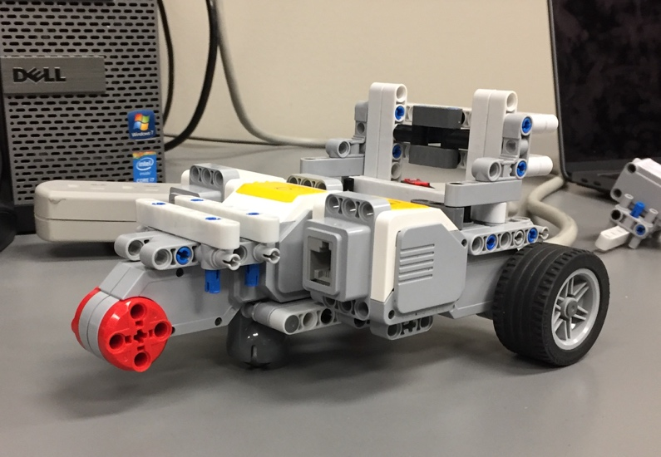

*Figure 7.1.1- Chassis*

*NXT Motor*

1. Due to all the sensors and motors that had to be added to the robot, the chassis needed to be as rigid as possible. The chassis is the foundation of the robot, a strong foundation is the only way towards building the best possible robot. The rigid chassis stabilized the robot to make sure the track is always constant and not changing during the code implementation.
2. The chassis was created such that the track was close to 13cm. This was done so that the robot can traverse through the bumps on the bridge more easily. If the track had a short distance, it would encounter a lot of problems since it would be absorbing more bumps. Limitation of the track was that the robot should ideally drive in the middle section of the bridge while also being able to fit the tunnel (approx. 16cm).
3. The wheelbase was extended as far as possible so that the localization can work effectively. Due to the uneven weight distribution, the marble only works well when it is placed as far back as possible.

**7.2 Variable Rear Wheel- “Landing Gear”**

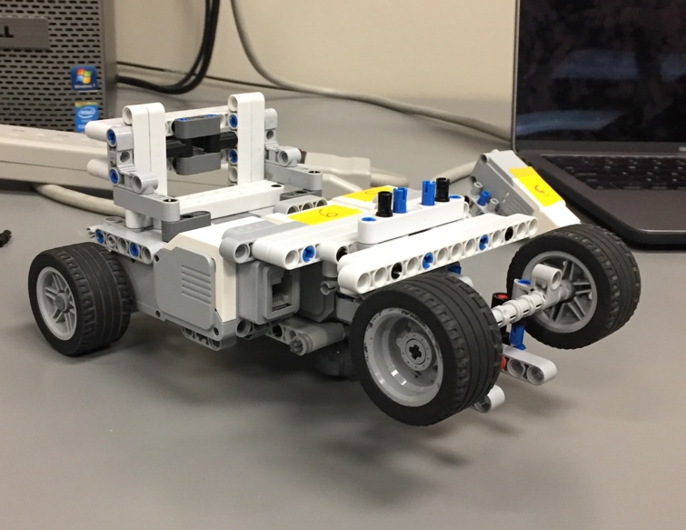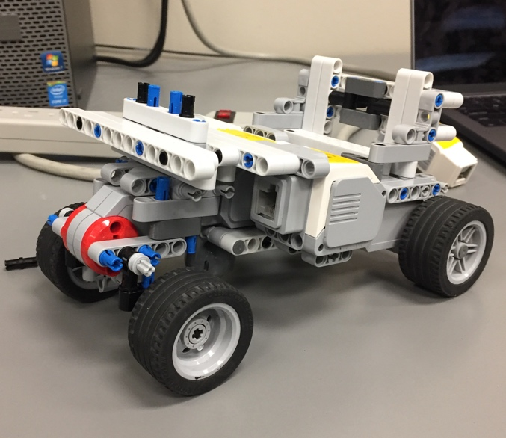

*Figure 7.2.2- Ejected Landing Gear*

*Figure 7.2.1- Stored Landing gear*

1. Through testing, it was seen that the robot traverses the bridge best when there is a stable wheel deployed in the rear. The main problem encountered when building a stable rear wheel is that the robot can’t localize or navigate. Keeping all this in mind, a mechanism was introduced where the rear wheel would only be deployed when it localizes towards the bridge. After driving through the bridge, the mechanism would lift the rear wheel, so the robot can localize using the marble.
2. Many limitations were encountered during the building process of the variable rear wheel. Due to the limited amount of space, the rear wheel had to be built efficiently. Moreover, small pieces which had a massive influence on the rear wheel.

**7.3 Light Sensor (Colour Detection)**

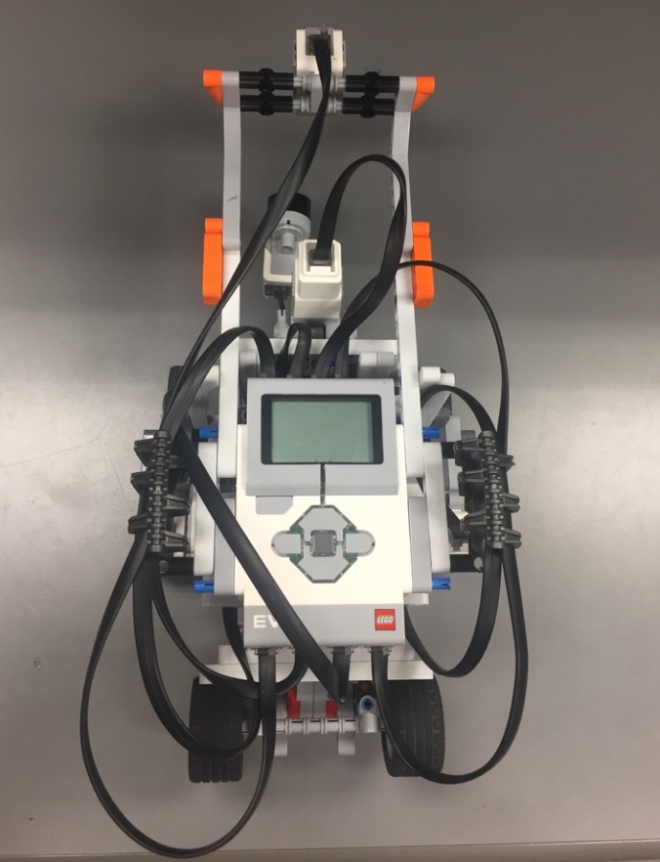

*Figure 7.3.1- Image depicting view of overhead light sensor*

1. Testing proved that the light sensor worked best when it was at a constant height. This allowed the light sensor to detect block colours at its optimal range at all times.
2. The light sensor that is used to detect the colour of the blocks encountered a few limitations. Due to the fact that the robot has the ultrasonic sensor in the same vicinity, the light sensor needed to be extended so that it can reach the blocks. Moreover, through the preliminary designs, it was stated that the light sensor would be placed at a constant height off the ground.

**7.4 Ultrasonic Sensor**



*Figure 7.4.1- Image showing the location of the ultrasonic sensor*

1. Due to our choice of attaching three light sensors to the robot, it left the robot with a single sensor port. Trying to optimize the performance of the robot with only one ultrasonic sensor, it was decided to attach the ultrasonic sensor to a medium motor. This allows the sensor to detect blocks in multiple locations with the use of only one sensor.
2. The best position for the sensor was located in front of the robot since that’s where the light sensor (colour detection) was located. The sensor had to be placed in a position such that it was not interfering with the light sensor (light sensor doesn’t detect the ultrasonic sensor). This condition left minimal area to work with when attaching the rotating ultrasonic sensor to the robot.

# 8 Final Design History

|  |  |  |  |
| --- | --- | --- | --- |
| **Description** | Keeps track of modification of the final design | | |
| **Created By** | Enan Ashaduzzaman, Hardware Lead | | |
| **Date Created** | 21st March, 2018 | | |
| **Version** | **Engineer** | **Summary** | **Date Modified** |
| 1.0 | Enan Ashaduzzaman | First version of final design created. | 21st March, 2018 |
| 2.0 | Enan Ashaduzzaman  Tianyi Zou | Rebuilt a second version of the final design from scratch fixing major problems on the robot. (Robot is not tilting downwards and the robot was condensed) | 25th March, 2018 |
| 2.1 | Enan Ashaduzzaman | Added guard rails to the robot so that the robot doesn’t get stuck when encountering the tunnel walls | 4th April, 2018 |
| 2.2 | Enan Ashaduzzaman | Right and Left motor replaced. Brick replaced. | 7th April, 2018 |